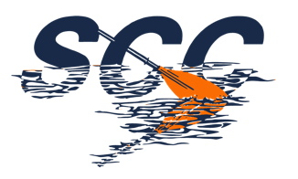

Club Safeguarding Statement / Policy
Shrewsbury Canoe Club is fully committed to safeguarding the well-being of its members. All members should show respect and understanding for the rights, safety and welfare of others, and conduct themselves in a way that reflects the principles of the Club.
We believe that taking part in Paddlesport should be a positive and enjoyable part of children’s lives and to achieve this have the following aims:
- • Club coaches and helpers should follow the British Canoeing Code(s) of Conduct.
- • All Club coaches, helpers and officials working with young people should read and adhere to the British Canoeing Safeguarding Children Policy and Safeguarding Adults Policy. The Club will follow the guidance of the policy in the event of any concerns or allegations.
- • The Club will ensure that anyone who meets the eligibly criteria for a Disclosure check will not be deployed until a satisfactory check has been returned.
- • All Club members are made aware of the Club Code(s) of Conduct.
- • The Club will obtain written medical details of young paddlers which will be made known to
coaches, where deemed appropriate and/or necessary.
- • Any paddler who coaches for the Club should be a member of British Canoeing. The club will encourage and support helpers to gain qualifications and assist coaches to stay updated.
- • The Club will identify a person whose role it is to deal with any issues concerning Safeguarding (Club Welfare Officer) and notify this person to all members. Anyone with concerns with respect to the welfare of a club member or participant should contact that person. If that person is unavailable they can contact the British Canoeing Safeguarding Officer (Tel: 0115 8968842)
- • The Club will adopt and regularly review a Health and Safety Policy.
- • The Club will review this Policy annually.
Signed: Nicholas J Morrall
Date: June 2022

